DIC Report

Name:- Mrunal Inge
UB ID: 50337040

Q1) Word Count: [word count of each words]

- Implemented word count, with java mapreduce. The mapreduce has two phases, map and reduce.
- In map phase, we split each line by a String tokenizer and then send each word as a key as “Text” with value as 1 as “IntWritable” to the reducer.
- Then reducer will receive all the values corresponding to a key, in the Iterable format.
- Then we sum all the values corresponding to the key and write it as output, using “context.write()”.

Output screenshot:
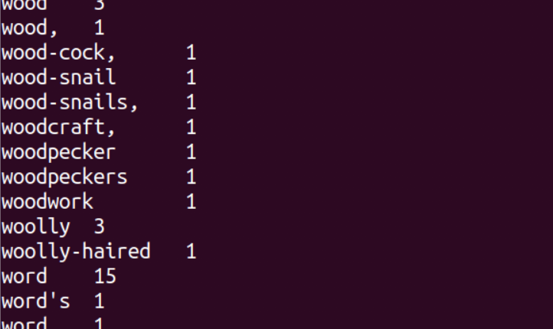

Q2) Ngrams:[Expected output: trigrams: count, top ten]

- In trigram implementation, the basic logic remains same as that of the word count example.
- First, in the line received from the mapper, we check for the keywords, science’, ‘sea’ , ‘fire’ and replace them all with “$” initially before starting processing on the line.
- Then, we split the line using string tokenizer and put it in an array.
- Then we put that in a list and find the index or occurrence of $.
- We take two s before that two words after that and put it in an array.
- Then we form trigrams with $ with all the elements in array, using an even smaller array.
- After one iteration of $ occurrence is done, we replace already used $ by # so that it would not be detected twice.
- Then we receive all the trigrams in an array list and send it as a Text and value as “1” to the reducer.
- The reducer will then calculate/ sum the total number of occurrences of each key/trigram and store it in a TreeMap.
- There is a comparator written for “Tree Map”, which will sort the key, value pair in descending order and then, from that we take the top 10 elements and write as output.
- The final sorting and context.write is written in “cleanup” method of reducer, since we need all the strings/trigrams with their occurrence sum together and only then we can sort. So, the sorting and final output logic goes in the cleanup method.

Output Screenshot:

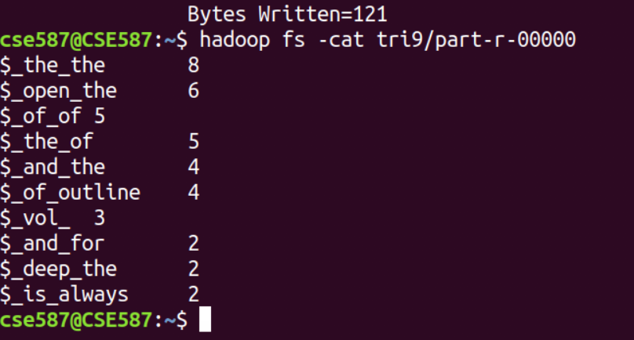

Q3) Inverted index [Expected output: ]

1) So basically inverted index is, number of occurrence of a particular word in all the input files given.
2) After removing the special character from the word, we write the word as key and the filename as value from the mapper to the reducer.
3) Created a hash-map and put the filename and the count of word related to that file. If a filename does not exist then we add the filename to the hashmap and set count to 1. If filename exists, then we increment the count of word corresponding of that file by 1.
4) Finally we write the word and hashmap, with the word and filename as the output of the write.

Output screenshot:
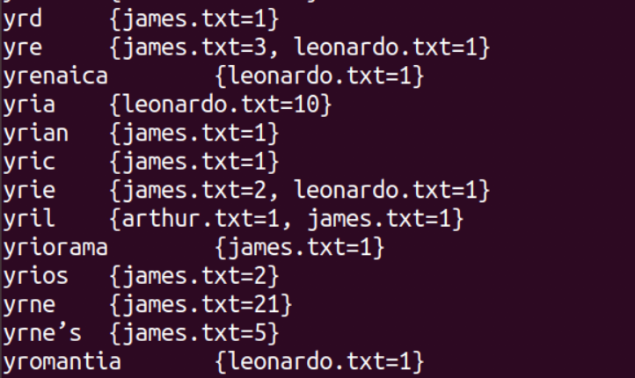

Q4) Relational Join: [Expected output: Entire table join]

- In the relational join, there are two files with two datasets.
- To get the join, we need two mappers, one for each database.
- In each mapper, we take the primary key and the columns associated with it.
- In the reducer, we get the primary key and all the column. Since the same primary key will get the columns. Then we append all the columns and write it as output.

Output screenshot:

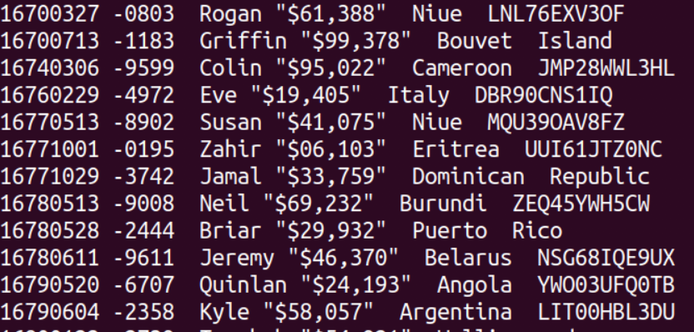

Q5) KNN: [Expected output: Test data row number with the label]
- According to basic KNN, we calculate the distance for each row in the test set with train set, sort the lowest distance in ascending order and then take the top K lowest distance neighbors and take the highest occurring label among those five and label that row accordingly.
- Here we have set K value to ‘5’. We will be taking 5 nearest neighbors.
- The mapper logic includes, loading entire training data, loading testing data line by line or row by row. Then calculating the corresponding distance and giving the top 5 sorted distances with label and Row number of test data to the reducer.
- Here I am using a POJO class in java in which I am setting, the label, Test data number and the distance for each row. I am returning the array list of top 5 objects and from that list, further we return the test data row number and the train data label.
- Then reducer, actually does the labelling part. It takes, test data label and corresponding training data labels.
- A hashmap is mad with training data label and the count of each label.
- I transferred all the counts to an arraylist and then sorted it in ascending order. Then I took the last count value, associated with corresponding label of training data and returned it with test data row number.
- Since the KNN code is taking a long time to run, so I have taken a small dataset. In the video, I have used only two rows for Test data.
- I have pre-loaded the train data in the code itself. For running the code you just need to pass the Test.csv file.

Output screenshot:

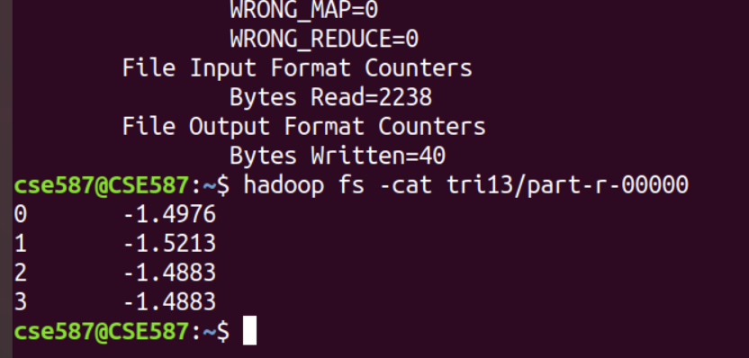

Youtube video link:

https://drive.google.com/open?id=1vF-aAaNSzleizwyqdIYszSL6D8OmfiAb

Commands to execute the code:

hadoop jar Desktop/join.jar assignment2.JoinDemo /join1/join1.csv /join1/join2.csv joiD
hadoop jar Desktop/invertedIndex.jar assignment2.InvertedIndexDemo /invert1 invert3
hadoop jar Desktop/ngram1.jar assignment2.TrigramDemo /demo/arthur.txt tri9
hadoop jar Desktop/wordCount.jar assignment2.WordCount /invert1/arthur.txt word1
hadoop jar Desktop/knn.jar assignment2.KNNDemo /knn/Test3.csv tri13

Referred to:

- Stackoverflow
- https://openproceedings.org/2013/conf/edbt/BerberichB13.pdf
- https://www.youtube.com/watch?v=Saq1QagC8KY
- https://hadoop.apache.org/docs/r1.2.1/mapred_tutorial.html
- https://en.wikipedia.org/wiki/Inverted_index
- https://www.youtube.com/watch?v=6kZ-OPLNcgE
- https://www.youtube.com/watch?v=8U7h3ZRtEQ
- https://docs.oracle.com/en/java/
- https://www.tutorialspoint.com/java/index.htm

